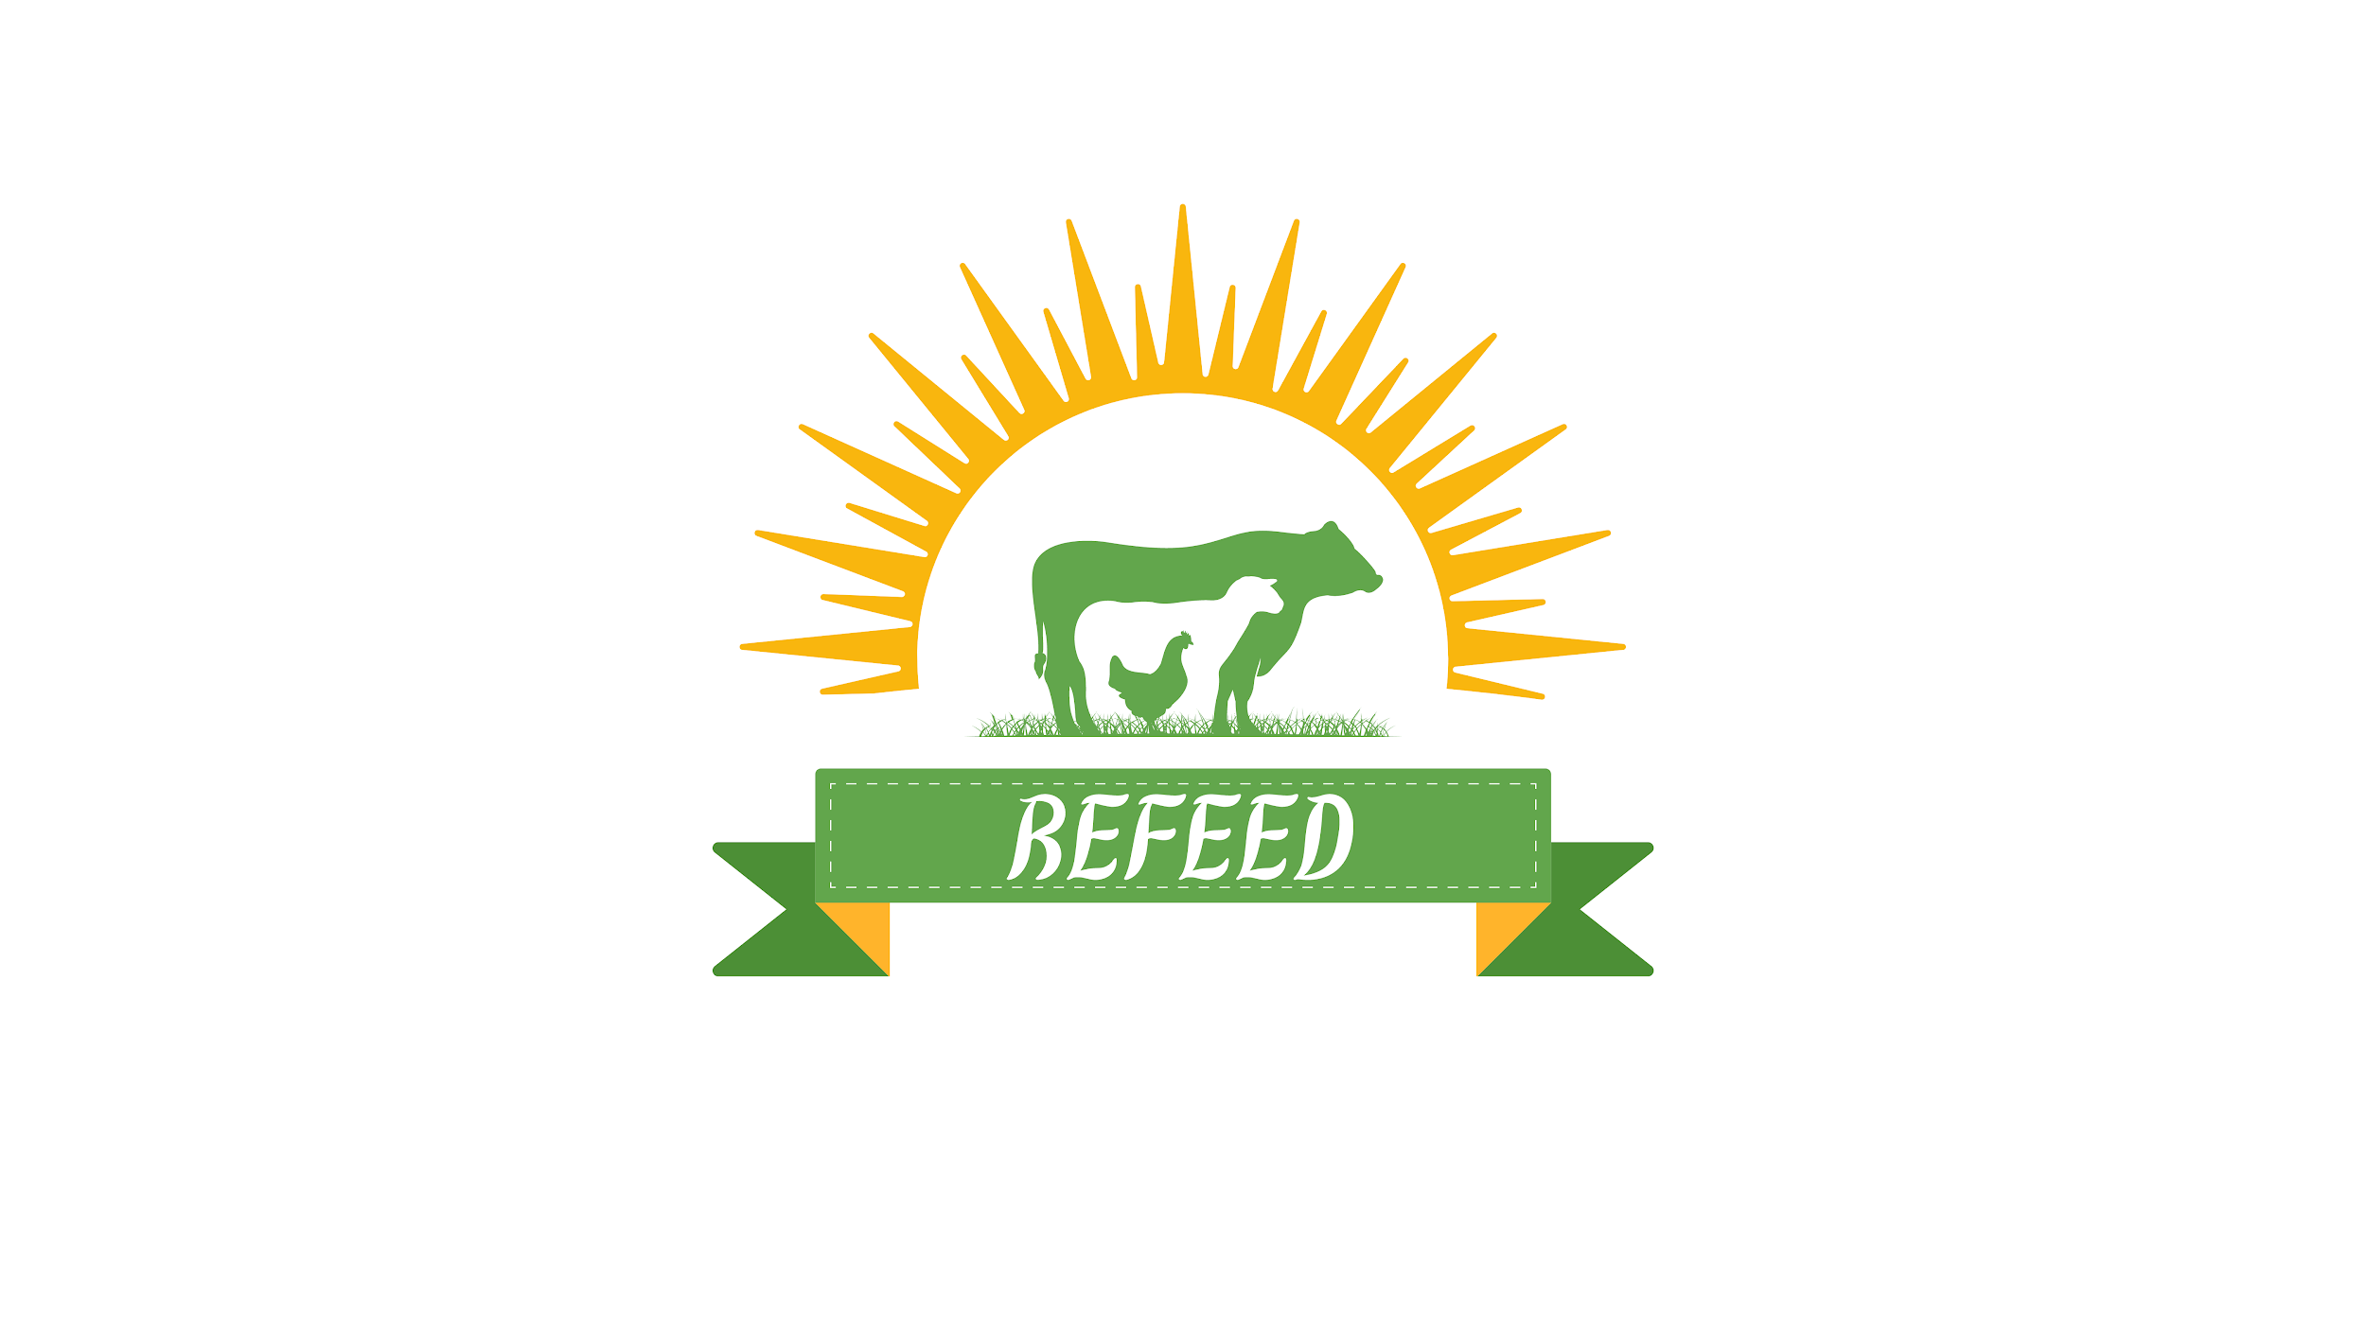

| **Operations** **& Training Risk Management Plan** | |  |
| --- | --- | --- |
| **Author:** Project Manager  **Status:** Draft / Final | **Created: October 24**  **Updated:** **October 25** |  |

# Objective

The objective of this document is to outline potential risks associated with the feed production project & aiming to recycle food waste into high-quality animal feed in Egypt.

This plan will detail mitigation strategies to ensure project objectives are met within the specified timeline and budget.

Executive Summary

The purpose of the ReFeed project is to establish a sustainable feed production system using local crops and food waste in Egypt.

The project aims to reduce dependency on feed imports, support local agricultural development, and offer an eco-friendly solution to food waste.

**RISK TYPE ONE: Going over the project budget**

| **Scenario** | **Risk to project (L/M/H)** | **Mitigation Plan** |
| --- | --- | --- |
| Unforeseen expenses related to raw materials, labor costs, or operational overhead may lead to budget overruns. | **H** | * Implement a detailed budget tracking system to monitor expenses closely. * Conduct regular budget reviews (monthly) to identify any deviations from the planned budget early. * Establish a contingency fund to cover unexpected costs, estimated at 10-15% of the overall budget. * Negotiate fixed-price contracts with suppliers to minimize price volatility risks. |
| Prices for essential raw materials (e.g., food waste processing equipment, packaging materials) may increase due to market Inflation or supply chain disruptions. | **M** | * Establish long-term contracts with suppliers to lock in prices for essential materials. * Identify alternative suppliers or materials that can be used if costs exceed the budgeted amount. |
| Environmental risks such as water shortages , climate change …etc | **M** | * Search for alternative solutions preparing ourselves for any potential risks in this area |

**RISK TYPE TWO: Falling behind the training schedule**

| **Scenario** | **Risk to project (L/M/H)** | **Mitigation Plan** |
| --- | --- | --- |
| Delays in training staff on new processes or equipment, potentially affecting production timelines and operational efficiency. | **M** | * Develop a comprehensive training schedule that allows for overlap with initial production phases. * Utilize experienced trainers and provide pre-training materials to enhance learning before formal sessions. * Monitor progress through regular feedback sessions and adjust the training pace as needed. * Include buffer time in the project schedule to accommodate potential delays in training. |
| Disruptions in the supply chain for raw materials or equipment can delay critical tasks, leading to missed milestones in the production schedule. | **M** | * Develop relationships with multiple suppliers to reduce dependency on a single source and ensure material availability. * Monitor supply chain trends and maintain an inventory buffer for critical materials to mitigate the impact of disruptions. * Create a contingency plan that identifies alternative materials or processes if primary supplies are delayed. |
| Competing priorities within the organization may lead to conflicts in resource allocation, causing delays in task completion and affecting project milestones. | **M** | * Clearly define project roles and responsibilities, ensuring alignment with organizational goals to secure resource commitment. * Regularly communicate project progress and needs to senior management to advocate for necessary resources. * Consider implementing a project management software tool to track resource allocation and identify conflicts early. |

Appendix:

**Probability chart:**

| **Probability** | | |
| --- | --- | --- |
|  | **Qualitative** | **Quantitative (if measurable)** |
| **Low** | Very low chance of risk occurring. | Less than <10% chance of risk occurring. |
|
| **Medium** | Medium chance of risk occurring. | 10%-49% chance of risk occurring. |
| **High** | High chance of risk occurring. | 50%-100% chance of risk occurring. |
|

**Impact chart:**

| **Types of Impact** | **Low** | **Medium** | **High** |
| --- | --- | --- | --- |
| **Financial** | Low financial impact,  costing the company $0-$14,000 | Medium financial impact,  costing the company $15,000-$29,000 | High financial impact,  costing the company $30,000 or more |
| **Operational** | Low impact to project operations, causing delays of a few days to a few weeks | Medium impact to project operations,  with potential to delay project by a month or more | High impact to project operations,  with potential to cause project failure |
| **People** | Low impact to employee attrition, with 5%+ of employees quitting | Medium impact to employee attrition, with 25%+ of employees quitting | High impact to employee attrition, with 50%+ employees quitting |

**Probability and Impact Matrix:**

| **Inherent Risk** | | | | |
| --- | --- | --- | --- | --- |
|  | | **Impact** | | |
| **Low** | **Medium** | **High** |
| **Probability** | **High** | Medium | High | High |
| **Medium** | Low | Medium | High |
| **Low** | Low | Low | Medium |